**COVID19 Labors Helpline Project Schema**

**ER DAIGRAM:**

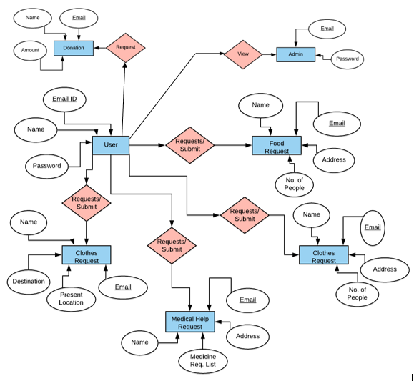

**DATABASE TABLE:**

*REGISTRATION TABLE:*

**STEP1:**

CREATE TABLE Registration

(

Name varchar2(40),

Email varchar2(40),

Password varchar2(40)

);

**STEP2:**

insert into Registration(Name,Email,Password) values('Jinappa','jinappa90@gmail.com','jinu123');

insert into Registration(Name,Email,Password) values('Robert','Robert670@gmail.com','Rob1@8987');

insert into Registration(Name,Email,Password) values('Fatima','fatimaA85@gmail.com','Rfat@6785');

**STEP3:**

**select * from Registration**

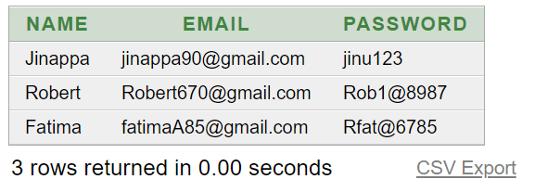

**STEP4:**

**Desc Registration**

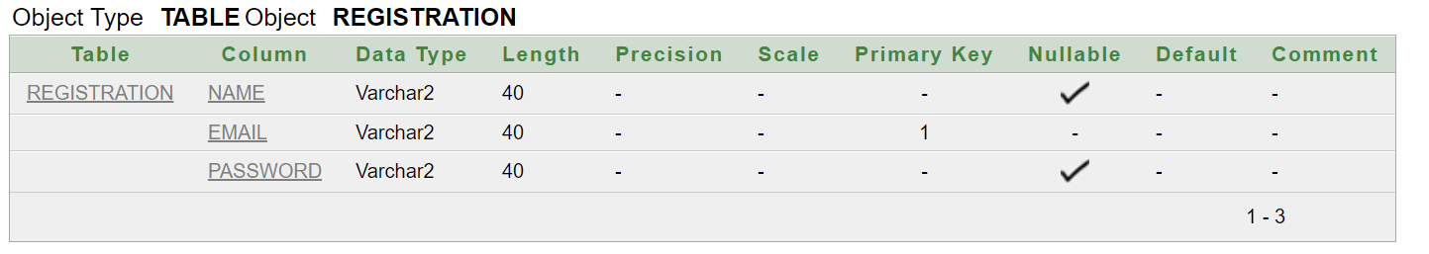

*LOGIN TABLE:*

**STEP1:**

create table login

(

emailvarchar(30),primary key(email),

passwordvarchar(20)

);

**STEP2:**

insert into login(Email,Password) values ('Robert670@gmail.com','Rob1@8987');

insert into login(Email,Password) values('fatimaA85@gmail.com','Rfat@6785');

**STEP3:**

**Select * from login;**

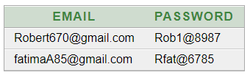

**STEP4:**

**Desc Login**

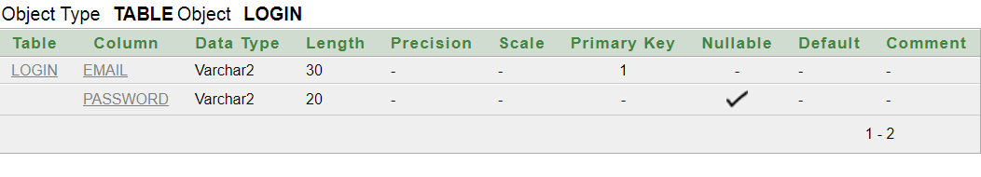

*FEEDBACK TABLE:*

**STEP1:**

create table feedback

(

name varchar2(30),

email varchar2(30)primary key,

message varchar2(200),

);

**STEP2:**

insert into feedback values(riya,'riya@gmail.com','satisfies and got help on time');

insert into feedback values(ram,'ram@gmail.com','satisfies and got help on time');

insert into feedback values('shree','shree@gmail.com','satisfies and got help on time');

**STEP3:**

**select * from feedback;**

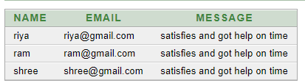

**STEP4:**

**desc feedback**

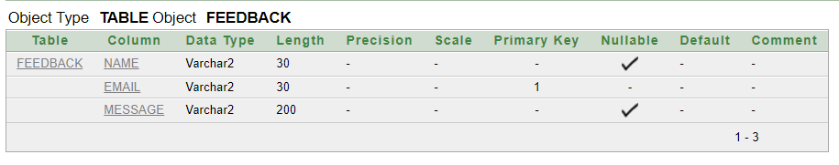

*REQUEST FOR FOOD TABLE:*

**STEP1:**

create table RequestFood

(

namevarchar(30),

emailvarchar(30), a

ddressvarchar(60),

NumberOfPeoplenumber,primary key(email));

**STEP2:**

insert into RequestFood values('Kavana','kavana@gmail.com','Bangalore', 4);

insert into RequestFood values('Naveen','Naveen@gmail.com','Mysore', 3);

**STEP3:**

**Select * from RequestFood**

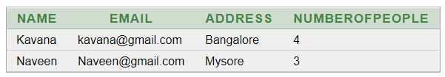

**STEP4:**

**DescRequestFood**

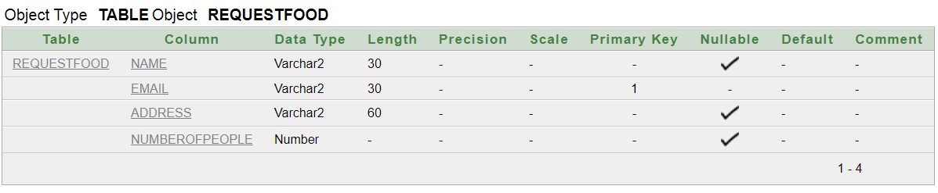

*REQUEST FOR CLOTHES TABLE:*

**STEP1:**

create table RequestClothes

(

namevarchar(30),

emailvarchar(30),

addressvarchar(60),

NumberOfPeople number,

primary key(email)

);

**STEP2:**

insert into RequestClothes(Name,Email,Address,NumberofPeople) values('Fatima','fatimaA85@gmail.com','RR Nagar Bangalore',2);

insert into RequestClothes(Name,Email,Address,NumberOfPeople) values('Jinappa','jinappa90@gmail.com','Yelahanka Bangalore',1);

**STEP3:**

**Select * from RequestClothes;**

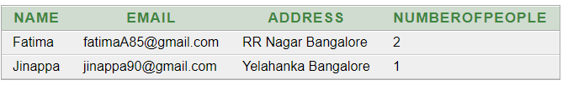

**STEP4:**

**DescRequestClothes**

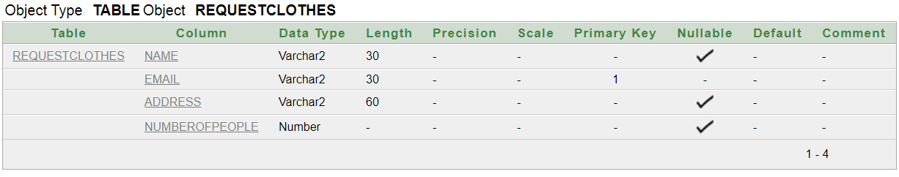

*REQUEST FOR MEDICATION TABLE:*

**STEP1:**

create table medical

(

email varchar2(30)primary key,

address varchar2(40),

medicine varchar2(100)

);

**STEP2:**

insert into medical values('shree@gmail.com','bangalore','medicine1');

insert into medical values('ram@gmail.com','kr puram','medicine2');

insert into medical values('riya@gmail.com','yelahanka','medicine1');

**STEP3:**

**select * from medical;**

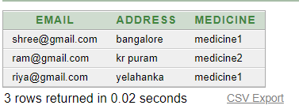

**STEP4:**

**desc medical;**

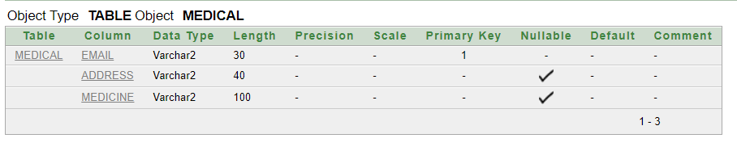

*REQUEST FOR TRAVEL TABLE:*

**STEP1:**

create table travel

(

email varchar2(30)primary key,

address varchar2(40),

paddress varchar2(50),

destination varchar2(40)

);

**STEP2:**

insert into travel values('geeta','geeta@gmail.com','hassan','udupi');

insert into travel values('sheetal','sheetal@gmail.com','kodagu','bangalore');

insert into travel values('dev','dev@gmail.com','bangalore','dharwad');

**STEP3:**

**select * from travel;**

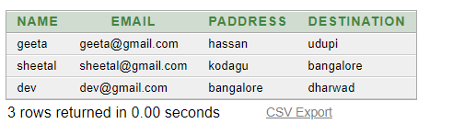

**STEP4:**

**desc travel;**

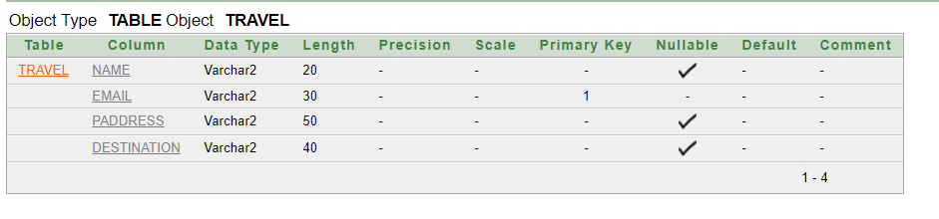

*DONATE TABLE:*

**STEP1:**

create table donate

(

name varchar2(30),

email varchar2(30)primary key,

amount number

);

**STEP2:**

insert into donate values('Seema','seemak@gmail.com', 5000);

insert into donate values('Nehal','nehal@gmail.com', 7000);

insert into donate values('Ronit','ronit@gmail.com', 3000);

**STEP3:**

**select * from donate;**

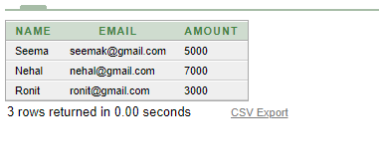

**STEP4:**

**desc donate;**

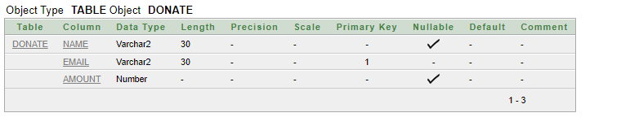

*VOLUNTEER TABLE:*

**STEP1:**

create table Volunteer

(

Name varchar2(40),

Email varchar2(40),

Address varchar(500)

);

**STEP2:**

insert into Volunteer(Name,Email,Address)values('Malini','mali@gmail.com','2nd block Btm banglore');

insert into Volunteer(Name,Email,Address)values('Remo','remoserro@gmail.com','#21street uttarahalli');

insert into Volunteer(Name,Email,Address)values('Fatima','mali@gmail.com','#21 sampige Banglore');

**STEP3:**

**select * from volunteer**

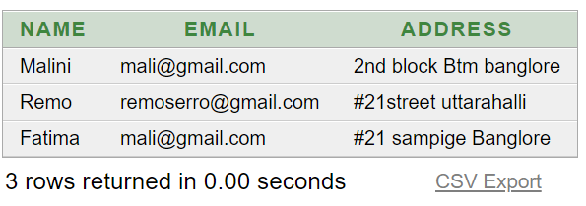

**STEP4:**

**Desc Volunteer**

